**Problem:**

You all must have seen a seven segment display.If not here it is:

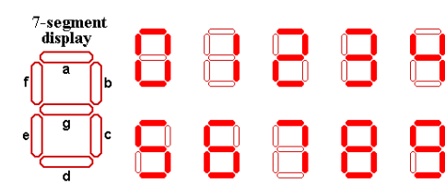

Alice got a number written in **seven segment format** where each segment was creatted used a matchstick.

Example: If Alice gets a number **123**so basically Alice used **12 matchsticks**for this number.

Alice is wondering what is the numerically largest value that she can generate by using **at most** the matchsticks that she currently possess.Help Alice out by telling her that number.

**Input Format:**

First line contains **T**(test cases).

Next **T**lines contain a Number **N**.

**Output Format:**

Print the **largest**possible number **numerically**that can be generated using **at max** that many number of matchsticks which was used to generate N.

**Constraints:**

1≤T≤100

1≤length(N)≤100

**Sample Input**

2

1

0

**Sample Output**

1

111